For Immediate Release on or after December 7, 2015
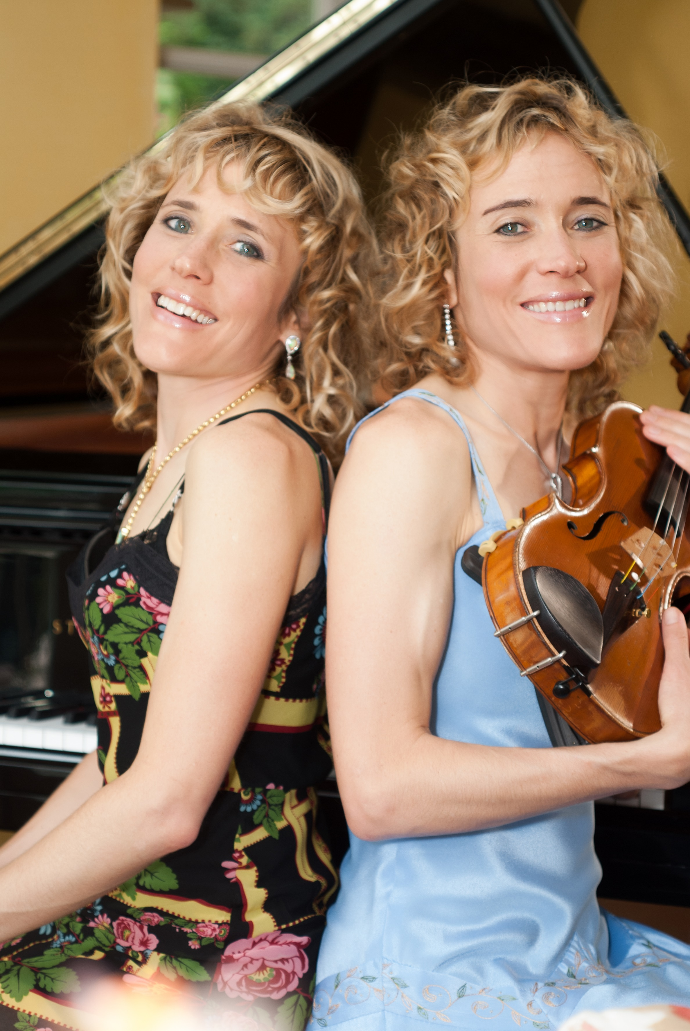
Music with a Mission – Acclaimed classical musicians Ambra and Fiona Albek of The Albek Duo will host An Evening of Music, a benefit concert in aid of The Children’s Haven of The Bahamas on Thursday, December 10, 2015 at 6:00pm The concert will be held at St. Paul The Apostle Catholic Church in Lyford Cay. Admission is free and open to the public. Donation envelopes will be available for those wishing to make a free will offering to support the work of The Children’s Haven of The Bahamas.

Acclaimed Albek Duo Host Free Benefit Concert
Swiss classical musicians host “An Evening of Music” benefitting the Children’s Haven of The Bahamas

Nassau, The Bahamas - Acclaimed classical musicians Ambra and Fiona Albek of the Albek Duo take center stage on Thursday, December 10 at 6:00 pm for an “Evening of Music,” a benefit concert in aid of The Children’s Haven of The Bahamas. The event will be held at St. Paul the Apostle Catholic Church in Lyford Cay. A reception with light refreshments will follow the concert.

Admission is free and open to the public. Donation envelopes will be available for those wishing to make a free will offering to support the work of The Children’s Haven of The Bahamas.

The Children’s Haven of The Bahamas is a non-profit organization that aims to empower the youth through education. Their mission is to reignite hope in young persons through an after-school program that includes tutoring, meal provision, art, music and competitive sports training.
“We are extremely excited to perform for such a worthy cause,” stated Ambra Albek, violinist. “The Bahamas has always been close to our hearts and we jumped at the opportunity to give back in a meaningful way.”

Guests will be treated to a number of selections including Johannes Brahms’ Scherzo in C minor, and César Auguste Franck’s Sonata.
Twin sisters Ambra and Fiona Albek have been playing music together since their early childhood. Their international concert career includes numerous festivals throughout Europe, the United States, Australia, South American and China. The Albek Duo have three albums to their credit, South of the Alps, Sounds in Search of a Past, and their latest, Roaring Dramas.

For more information or to make a private donation to The Children’s Haven of The Bahamas call 242-502-9407.

###

