

Events & Highlights

HOME INTERNATIONAL ARTISTS CHAMBER MUSIC
Chamber Music
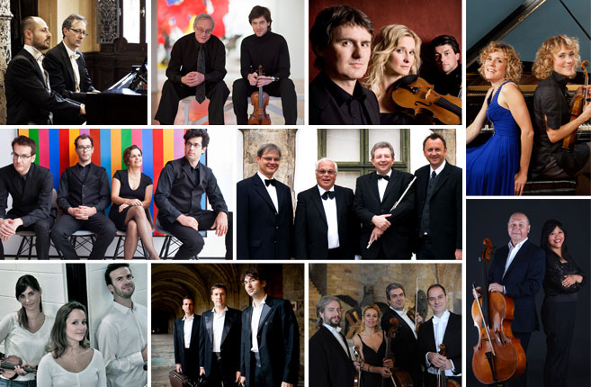
It is the chance to hear the best artists up close in intimate settings with superb textural clarity. In each group, not only does the individual technical excellence and balance between the members contribute to its remarkableness, but also the richness of ensemble, where the harmonic construction and musical understanding are perfectly mirrored with coherent phrasing and homogeneous ensemble playing, thus revealing a profound expression of the music piece. The resulting intimacy suggests "smallness" and "closeness" on the participation of both performers and listeners. Wu Promotion believes that it is only a matter of time for Chinese audience to become fervently infatuated with the ultimate delicacy of chamber music.

Trio Arcadis, France, 2013

Read more

Bruno-Valcepina Piano Duet, Italy - 200th Birth Anniversary of Verdi, 2013

Read more

Kitt - Labra-Makk Cello Piano Duo, Austria, 2013

Read more

Albek Duo, Switzerland, 2013

Read more

Swiss Piano Trio, Switzerland, 2013

Read more

Harrington-Lewis Violin Piano Duo, Ireland/USA, 2013

Read more

Trio Lenitas, Switzerland/France, 2013

Read more

Umbria Ensemble, Italy, 2013

Read more

Quatuor Molinari, Canada, 2013

Read more

Vienna Symphony Virtuosi, Austria, 2013

Read more

